OLYMPICS SQL QUERY REPORT

WHICH TEAM HAS WON THE MAXIMUM GOLD :

SELECT team,COUNT(distinct event) as cnt

FROM olympics.athlete_events ae

INNER JOIN olympics.athletes a

ON ae.athlete_id=a.id

WHERE medal='Gold'

GROUP BY team

ORDER BY cnt desc;

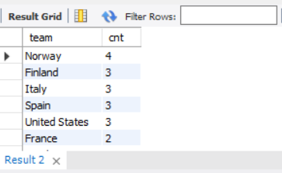

TOTAL SILVER MEDALS WON B Y EACH TEAM AND THE YEAR WHERE THEY'VE WON THE MAXIMUM SILVER MEDALS :

WITH CTE AS (

SELECT a.team,ae.year , COUNT(DISTINCT event) as silver_medals

,RANK() OVER(PARTITION BY team ORDER BY COUNT(DISTINCT event) DESC) as rn

FROM olympics.athlete_events ae

INNER JOIN olympics.athletes a

ON ae.athlete_id=a.id

WHERE medal='Silver'

GROUP BY a.team,ae.year

)

SELECT team,SUM(silver_medals) as total_silver_medals, MAX(case when rn=1 THEN year END) as year_of_max_silver

FROM CTE

GROUP BY team

ORDER BY total_silver_medals DESC;

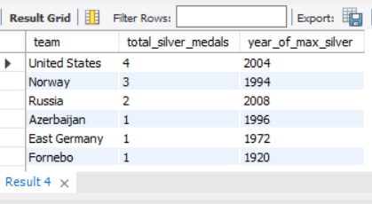

PLAYER WHO HAS WON MAXIMUM GOLD MEDALS AMONGST ALL THE PLAYERS :

WITH CTE AS (

SELECT name,medal

FROM olympics.athlete_events ae

INNER JOIN olympics.athletes a

ON ae.athlete_id=a.id

)

SELECT name, COUNT(1) as no_of_gold_medals

FROM CTE

WHERE name NOT IN (SELECT DISTINCT name FROM CTE WHERE medal in ('Silver','Bronze'))

AND medal='Gold'

GROUP BY name

ORDER BY no_of_gold_medals DESC

LIMIT 1



-- YEAR WISE ANALYSIS ON WHICH PLAYER HAS WON MAXIMUM GOLD MEDALS EACH YEAR.

WITH CTE AS (

SELECT ae.year,a.name,COUNT(1) as no_of_gold

FROM olympics.athlete_events ae

INNER JOIN olympics.athletes a

ON ae.athlete_id=a.id

WHERE medal='Gold'

GROUP BY ae.year,a.name

)

SELECT year,no_of_gold,GROUP_CONCAT(name,',') as players

FROM (

SELECT *,

RANK() OVER(PARTITION BY year ORDER BY no_of_gold DESC) as rn

FROM CTE) a

WHERE rn=1

GROUP BY year,no_of_gold

